# CAR BREEZY

|  |  |
| --- | --- |
| Supervisor. | **Miss** **Ramsha** |
| Batch. | **2310F1** |
| Group. | **A** |

|  |  |  |
| --- | --- | --- |
| Serial No. | EnrollmentNumber | Student Name |
|  | Student 1527146 | Hareem Fatima |
| 2. | Student 1521664 | Anmol Naz |
| 3. | Student 1525611 | Saba |
| 4. | Student 1521662 | Hafsa Abid Lodhi |

ACKNOWLEDGEMENT :

The first, we would like to express my special thanks of gratitude to my teacher <<Miss Ramsha>>, who helped us a lot in finalizing this project within the limited time frame, valuable counselling and assistance for the accomplishment of this project.

Secondly we would also like to thank the eProject team at Aptech Head Office, who gave us the golden opportunity to do this wonderful project about Car Breezy.

Thirdly, we also thank the eProject team, some of the benefits are as under:

* Re-enforcement of skills happens in the experiential learning process. 
* A mentor, ensuring that we do not get drifted, constantly guides us. 
* It gives us a lot of confidence to face an interview as we have worked on a project. We can explain virtually everything on the subject we have learnt. 

***SYNOPSIS***

Follow the strong development of the internet, technology cars and the growing cars market, every business needs a website design to display products on the internet.

The following Cars product are designed with many different designs, suitable for all styles and preferences, which are the most special suggestions from Car Breezy.

Attached are the introductions hidden behind the car gift from the gift you want to send to your lover, colleagues or loved ones.

So car breezy shares the best product images through the website for everyone to know.

However, purchases are not made directly on the website

***PROBLEM DEFINITION***

Car Breezy is into business of manufacturing and selling cars. They have been advertising about their cars through newspapers, pamphlets, television. Now with changing times, they have decided to go online as customers today use Internet extensively. They have planned for a website with complete details about their cars So, we solved many particular queries as followed:

* How the sitemap possibly looks alike?
* What information should be displayed on each page?
* How to put every comment is friendly?
* How to give users the best experience when using the website?
* How to let the website properly functioning along with the system requirement?
* Will the user be able to contact with Car Breezy company for advice?

CUSTOMER REQUIREMENT

SPECIFICATION (CRS)

After discussion, we are supposed to create a website for them with the

below mentioned requirement specifications:

• The Home Page should have suitable logo, and decent colour

combination. 

• The site should display a menu which will contain the options as Products,

Technology, Store Locator, Support etc. 

• Various pages having information about different types of cars, Technology used in the cars etc. 

• The information should be categorized according to different Product

Line-up e.g. “SPORTZ”, “PREMIER” etc. 

• When a user selects any product line-up, complete list of watches for

that product line-up will be displayed. 

• Details of the cars should be displayed on the Web Page along

with the title and it should be stored in Individual Word documents which can be downloaded or viewed by the User who wishes to see the same. 

• Price List for all cars should be available for download. 

• There should be a “Contact Us” page which will have the Address of

the Stores selling cars and the mail address which when clicked will

invoke the local mail client from where they can send an email. Address of the

Company should be displayed using GeoLocation API (eg. GoogleMaps).  

SCOPE OF THE WORK (IN BRIEF)

The website is to be developed for the Windows Platform using HTML5,

JavaScript and Geolocation. The site should work well in all leading browsers

including Chrome, IE, Firefox etc..

Homepage show Top best sell items, big sale, collection, new shop...

Every content direct to relative content.

WIREFRAME

1. **INDEX PAGE:**

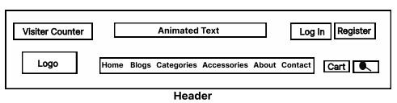

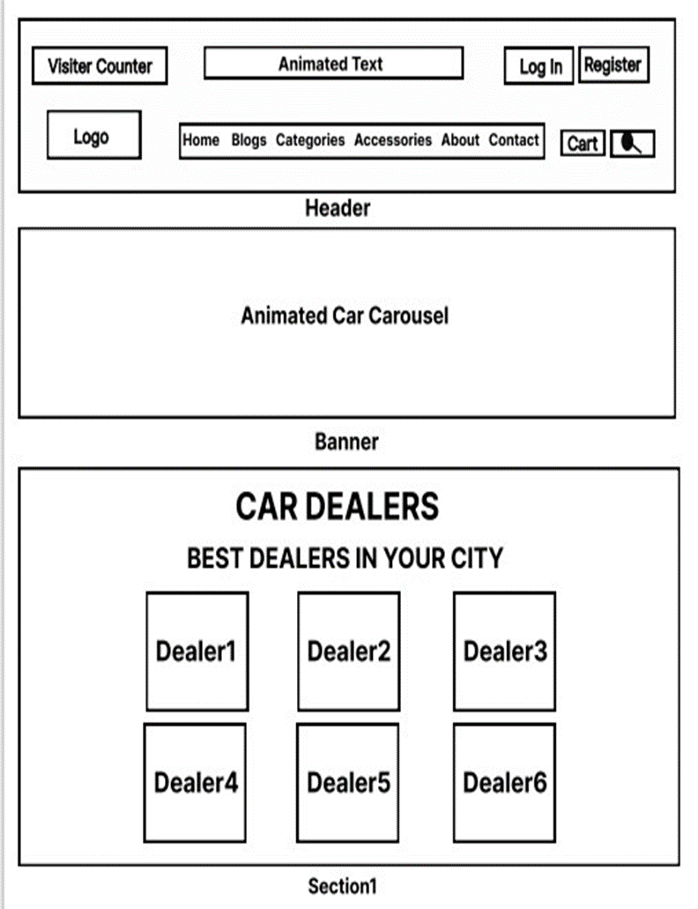

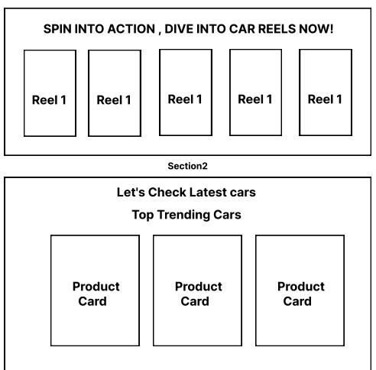

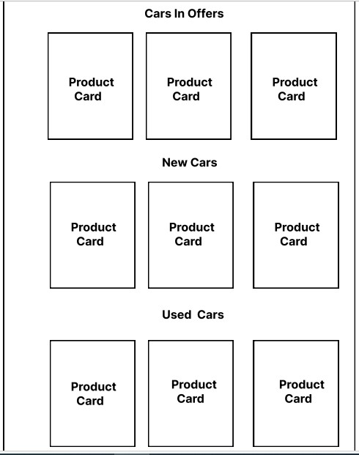

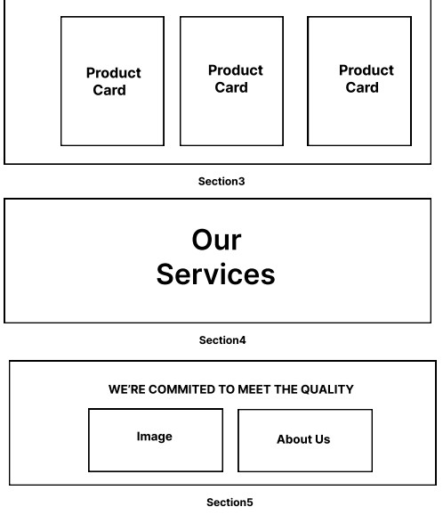

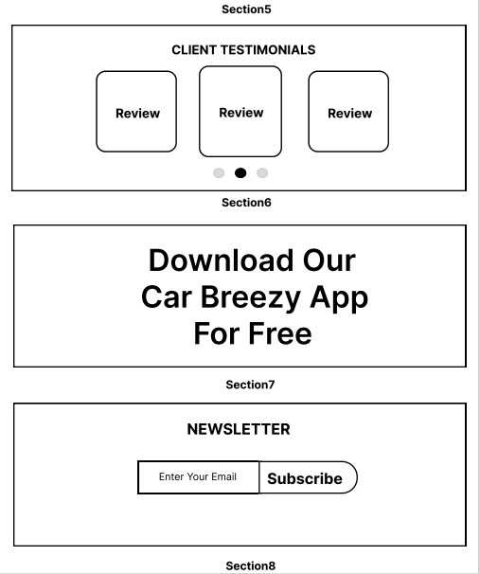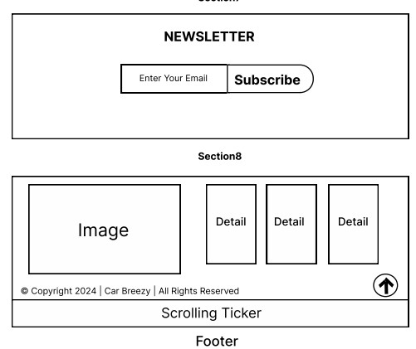

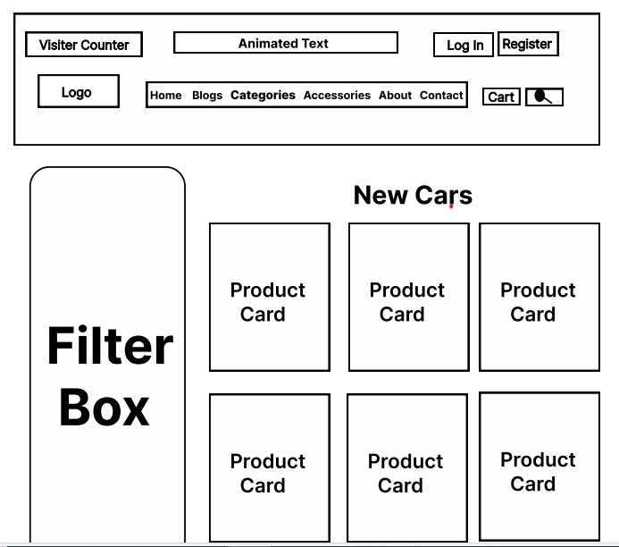

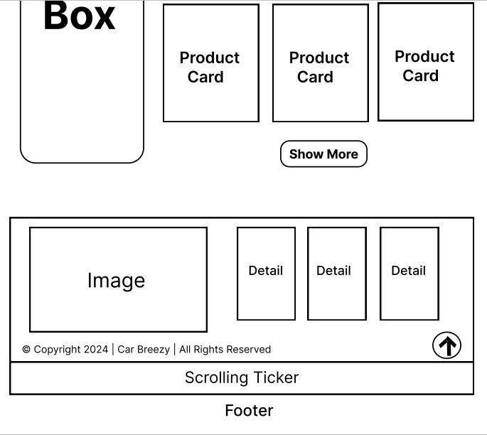

**

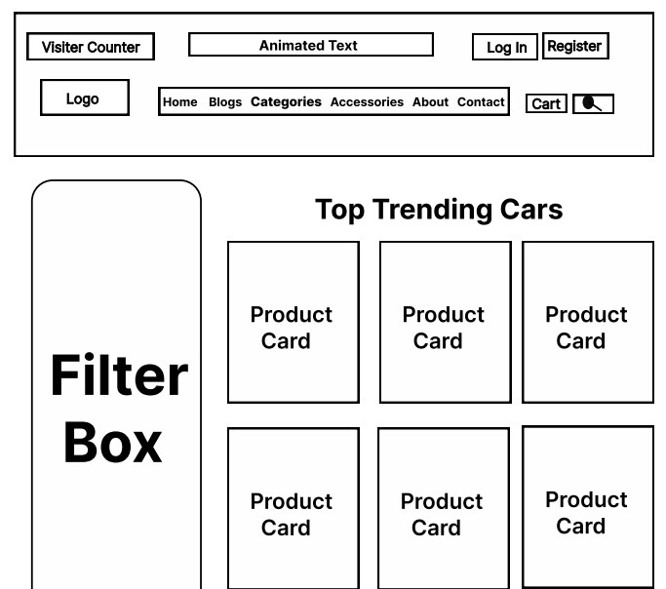

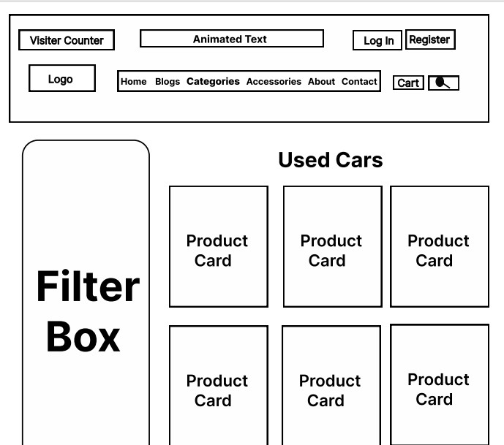



**3.OFFERS**:

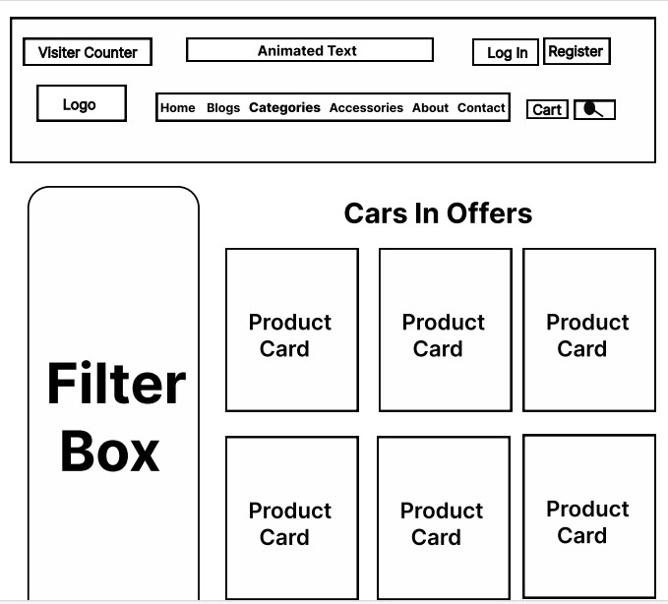

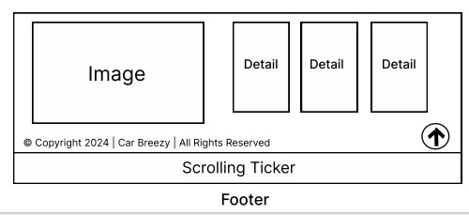

**4. ABOUT:**

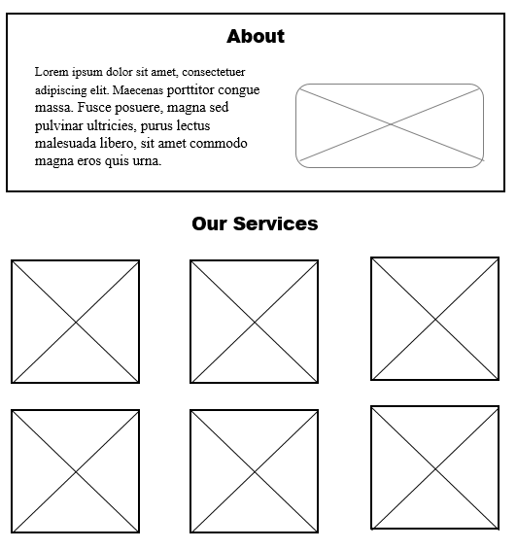

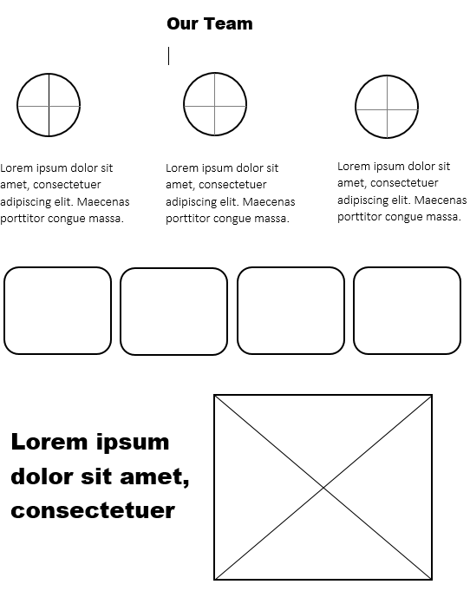

**5. ACCESSORIES:**

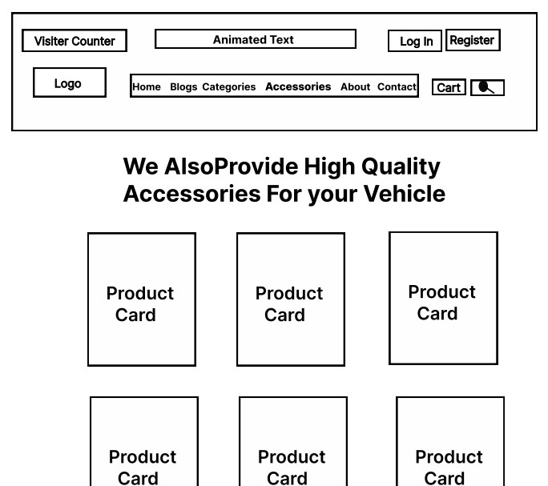

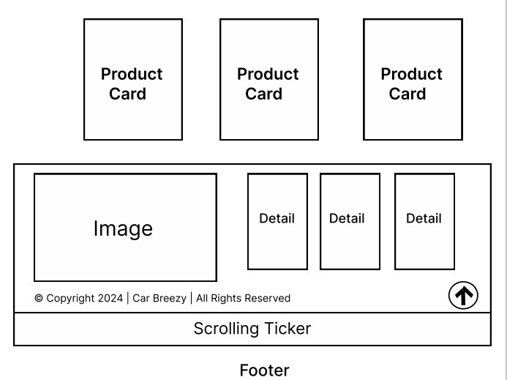

**6.BLOGS:**

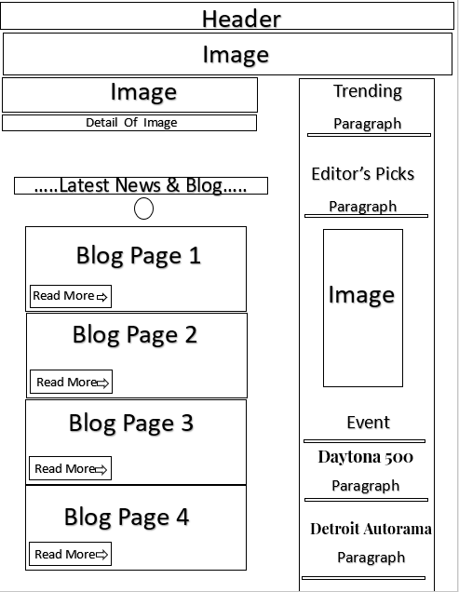

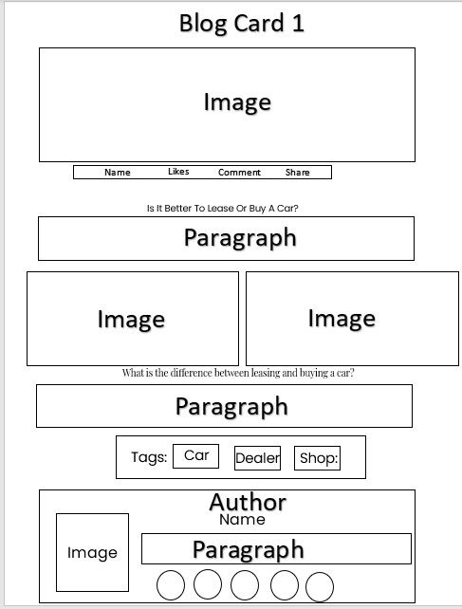

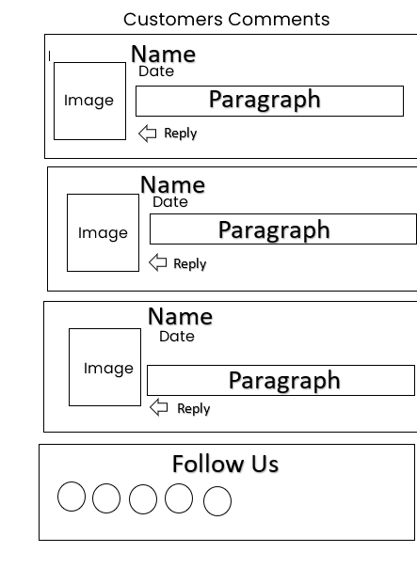

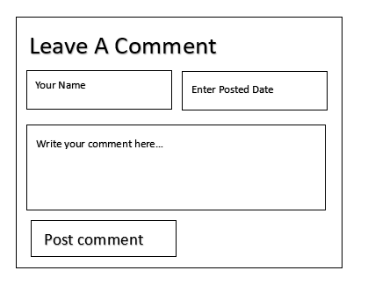

**7.CONTACT**:

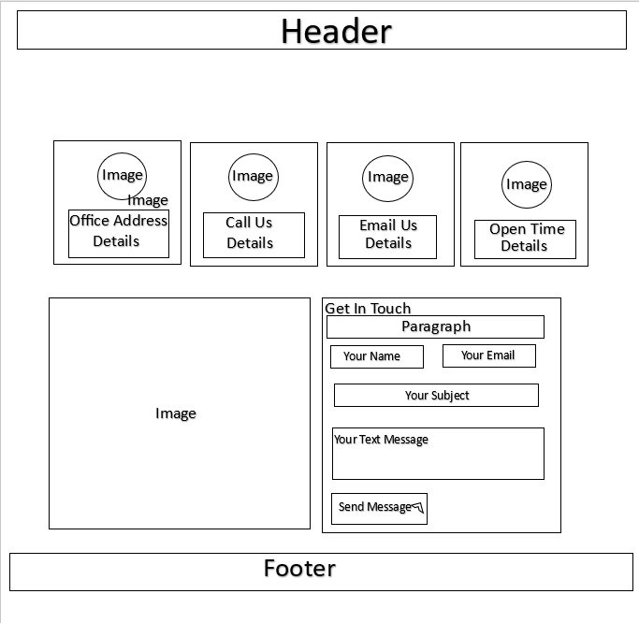

HEADER:

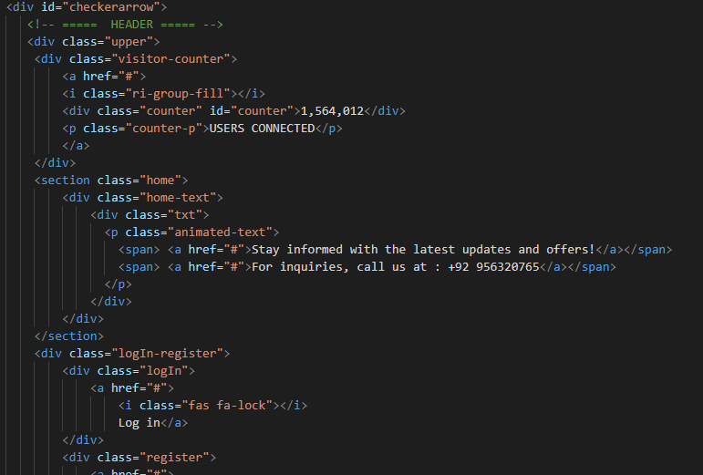

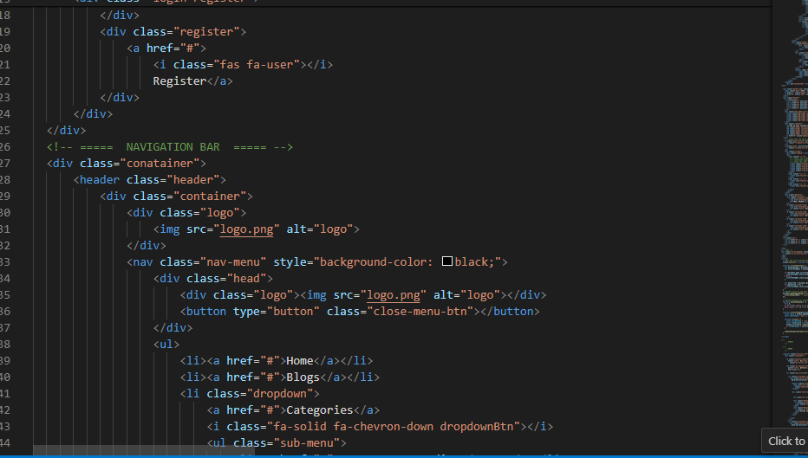

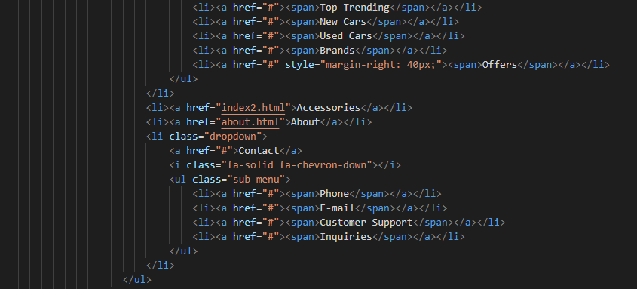

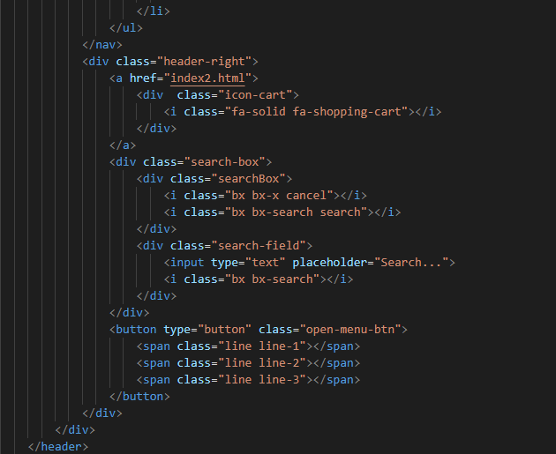

* The HTML code structures a webpage with essential features like a visitor counter, navigation bar, login/register section, and a stylish header encompassing a logo, menu, shopping cart, and search functionality.

BANNER

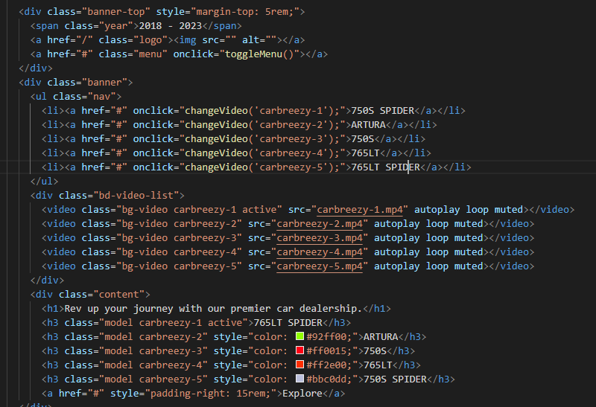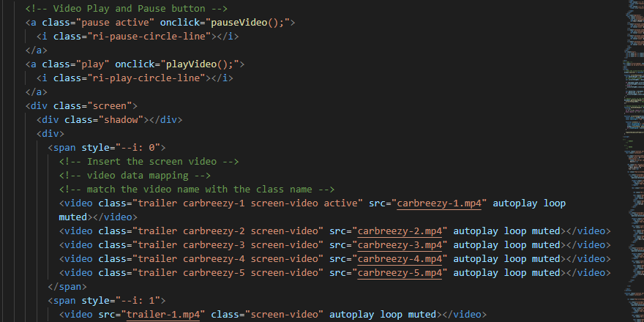

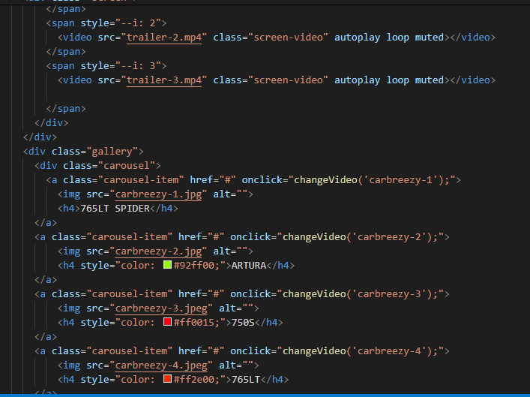

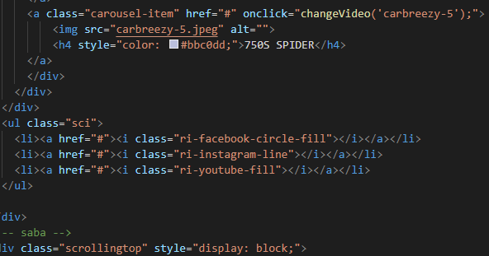

* This HTML code crafts a sleek webpage for a car dealership, offering a captivating banner, a menu for easy navigation, and a dynamic video carousel showcasing different car models. It also includes social media links for further engagement.

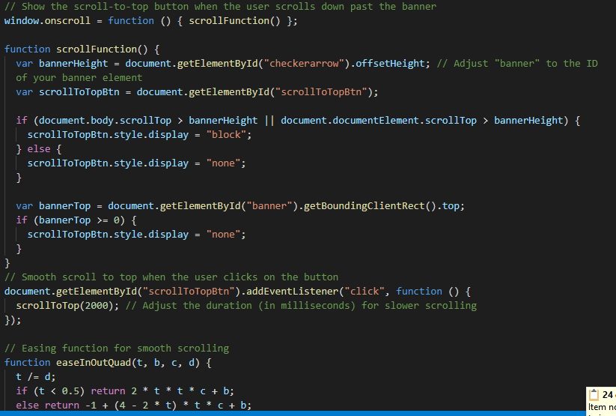

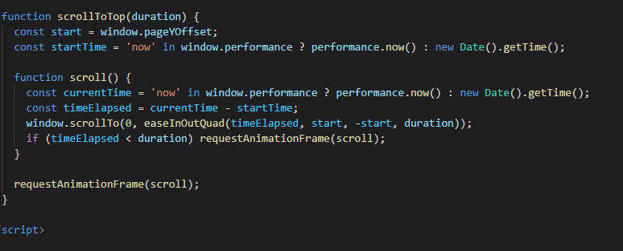

* This JavaScript code makes a button appear when you scroll down past the banner on a webpage. When you click the button, it smoothly takes you back to the top of the page. It also uses a special method to make the scrolling feel nicer.

TOP TRENDING:

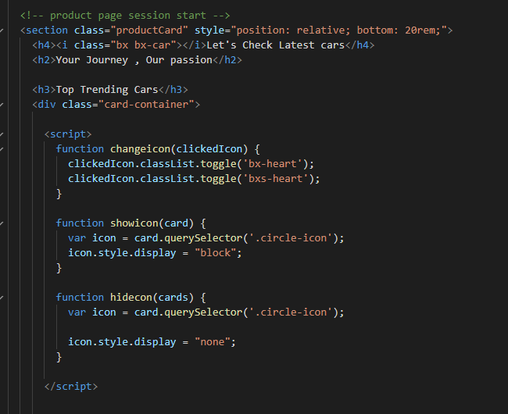

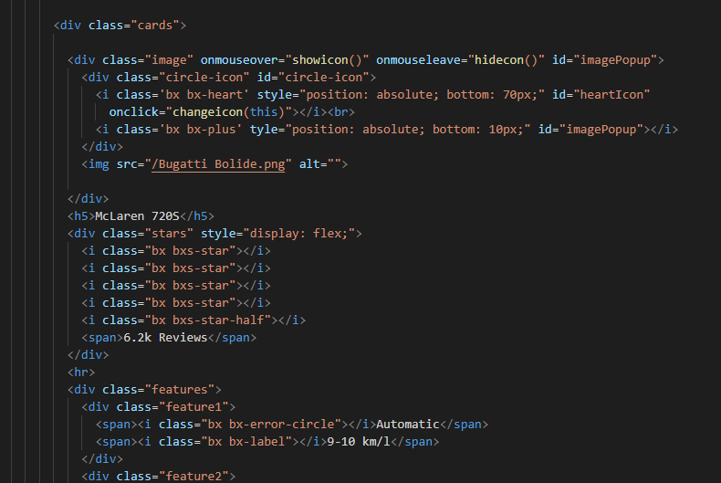

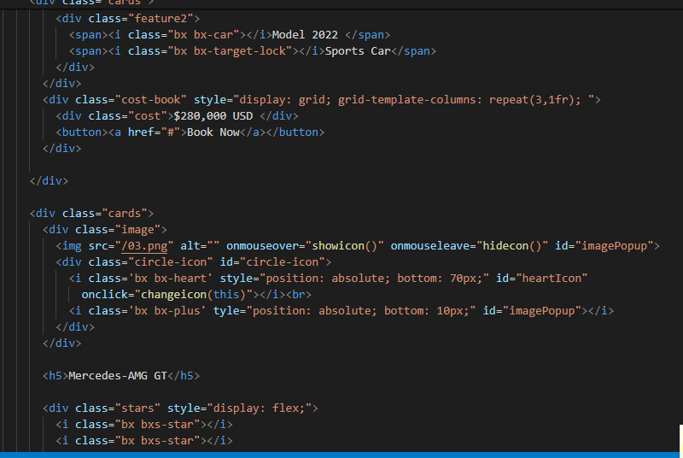

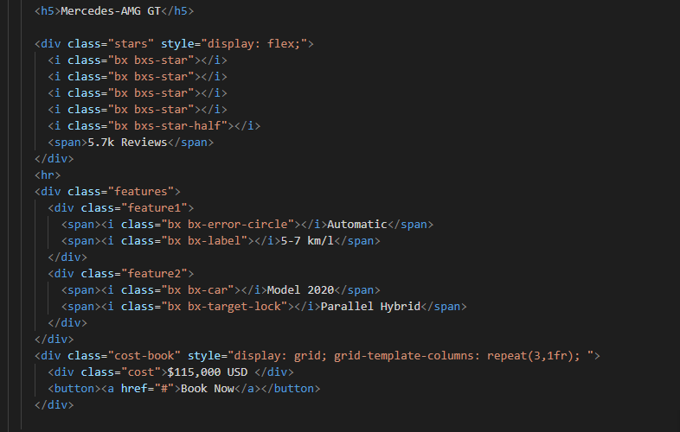

* This code creates a section showing different cars with images, names, reviews, features, and prices. Users can hover over the car images to see interactive icons like hearts and plus signs. Each car also has a "Book Now" button for easy booking.

SERVICES:

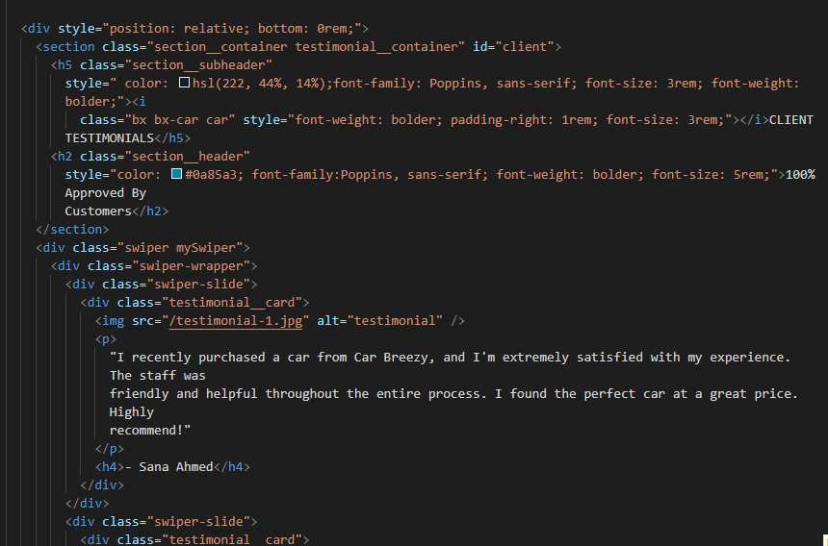

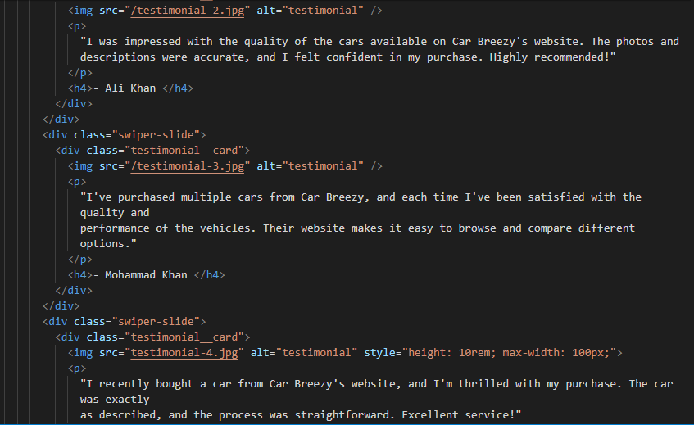

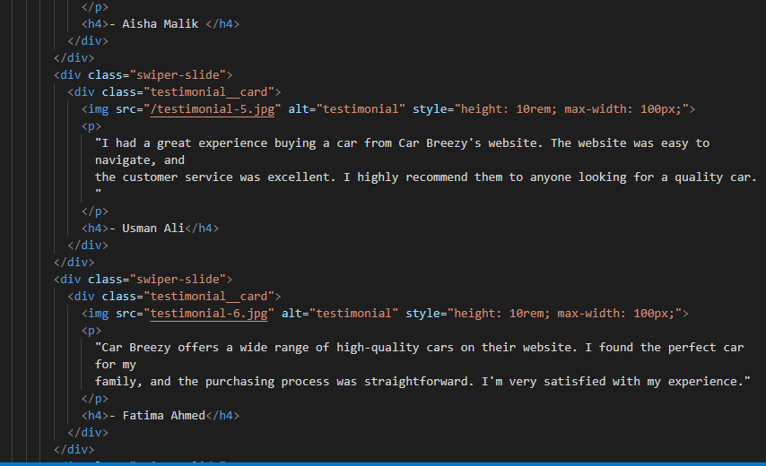

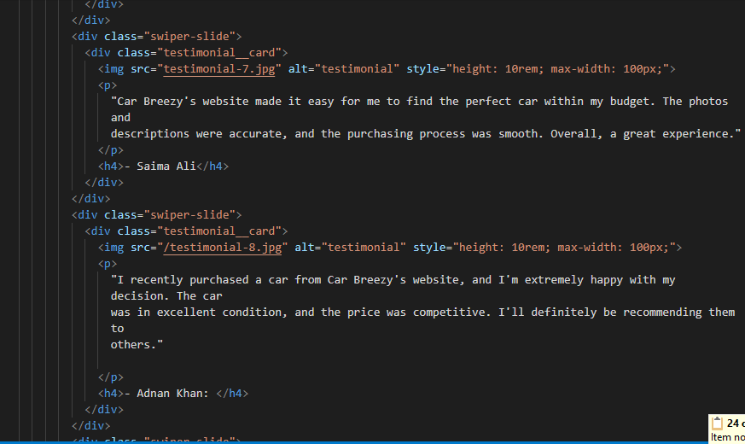

1. A section showing company details like team members and years in the market.
2. Another section displaying testimonials from happy customers, each with a photo, comment, and customer name.

These sections aim to highlight the company's credibility and positive customer experiences.

FOOTER:

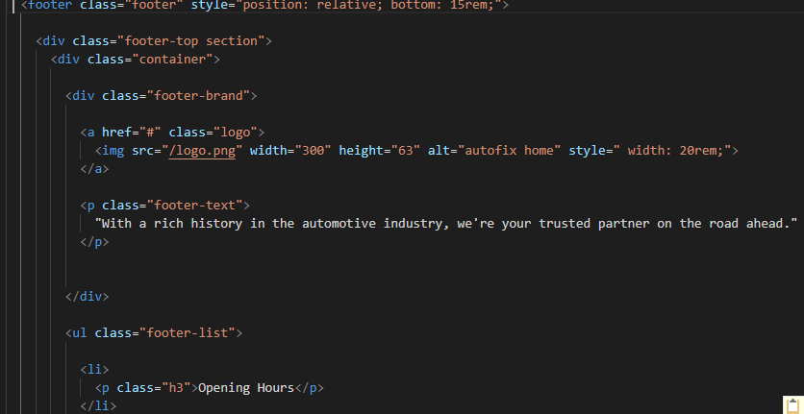

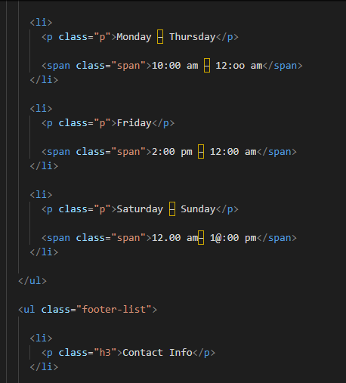

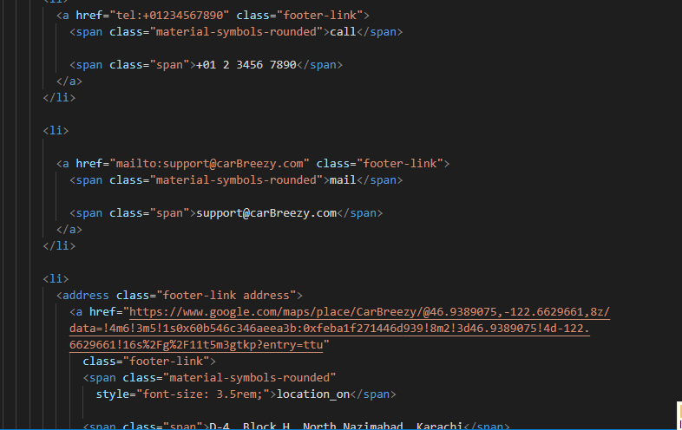

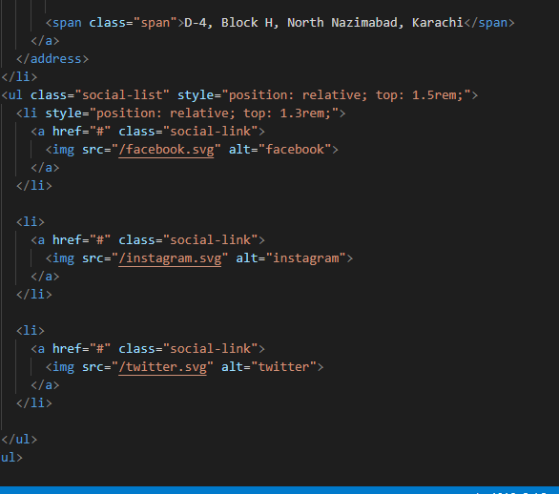

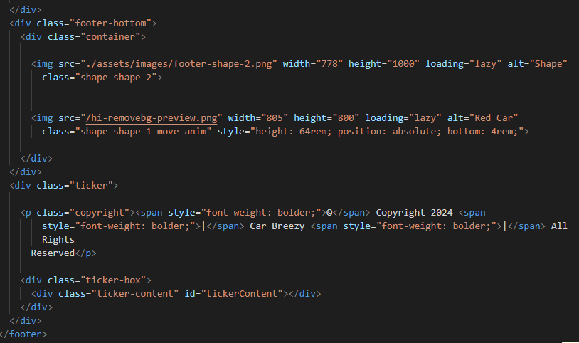

* This HTML code creates the footer section of a website. It contains details like company information, contact details, social media links, and a copyright notice. It's like the final goodbye of a webpage, giving users important information and links before they leave.

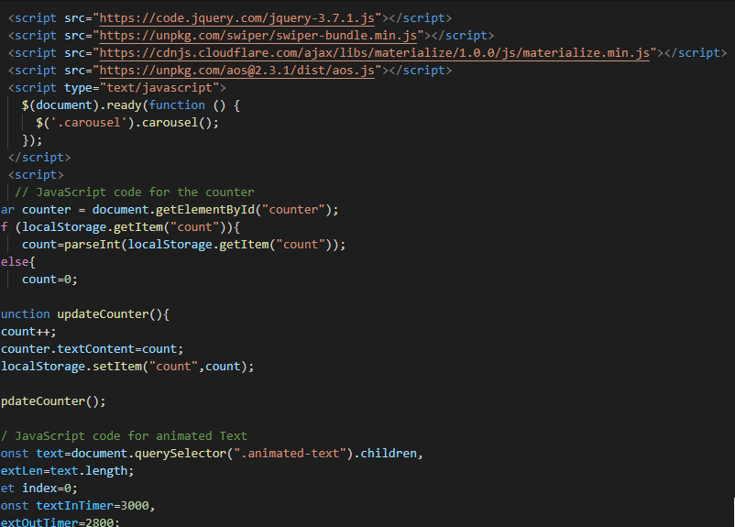

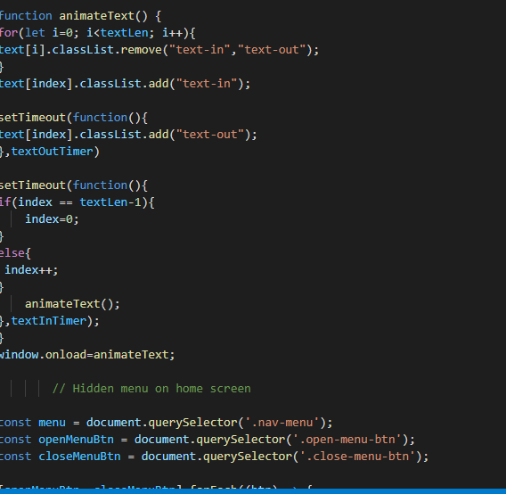

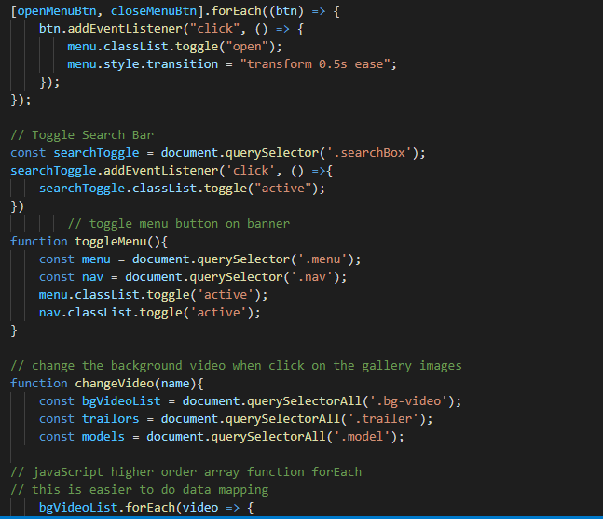

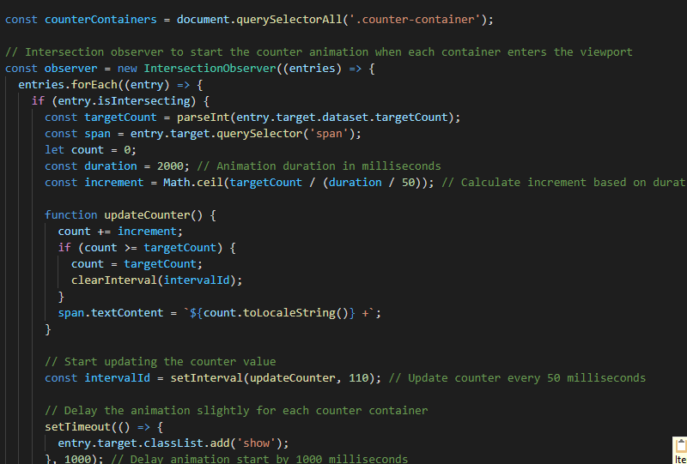

* 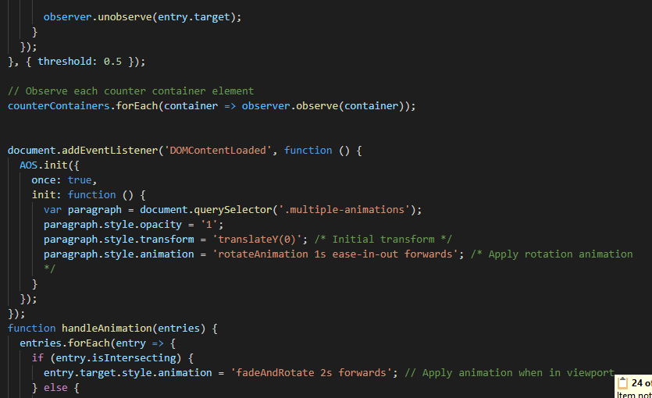
* This JavaScript code makes the webpage more interactive and engaging. It counts clicks, animates text, controls menus and search bars, changes content based on clicks, and handles form submissions. It also updates a scrolling ticker with current date, time, and location.

ABOUT US:

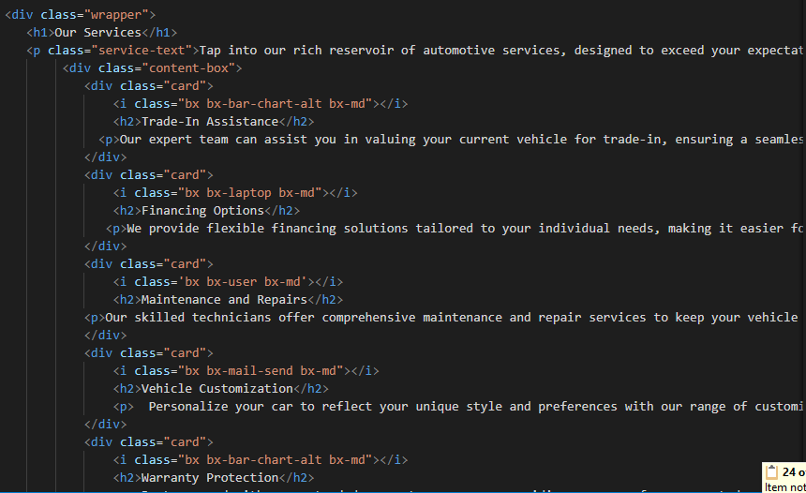

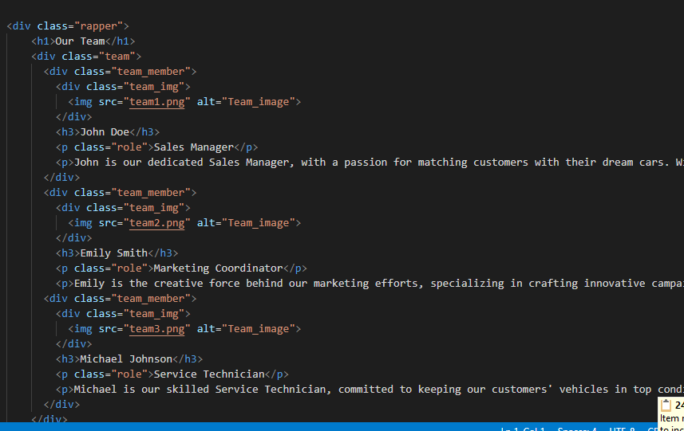

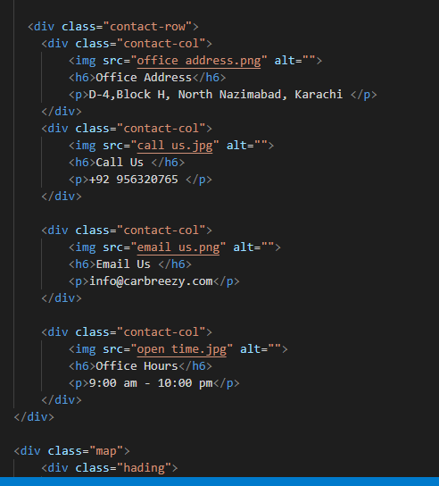

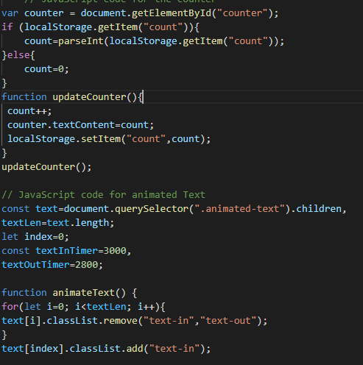

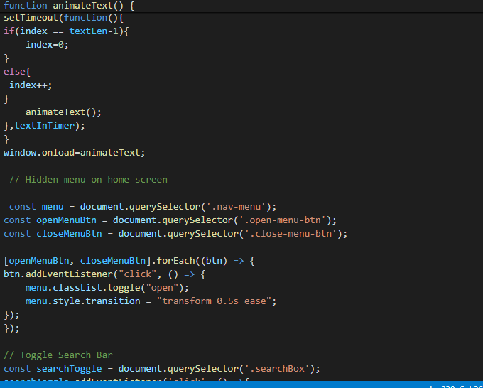

* This HTML code creates a webpage layout with sections for services, team members, contact information, and a map. It displays details about services offered, introduces team members, provides contact details like address and phone number, and includes an embedded map for location reference.
* Keeps track of how many times the page is loaded and saves it locally.
* Animates text on the webpage.
* Shows or hides a menu when a button is clicked.
* Shows or hides a search bar when clicked.

Top of Form

Top of Form

ACCESSORIES:

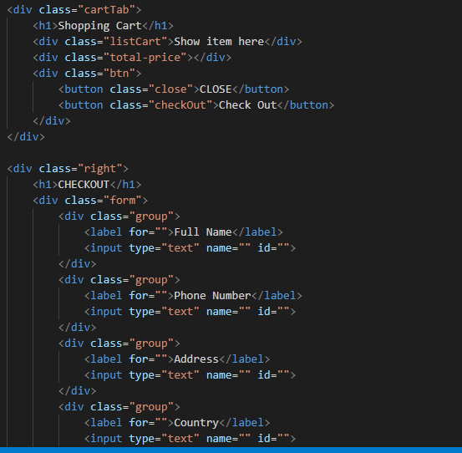

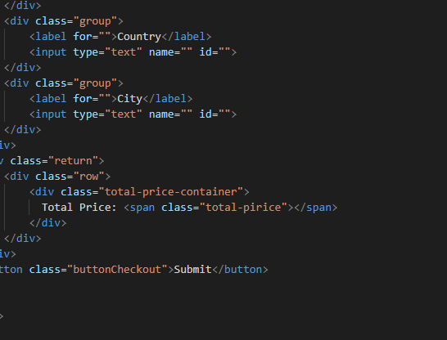

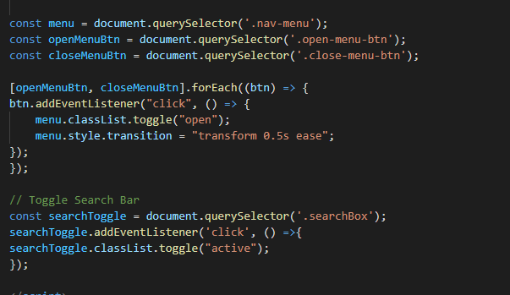

* This HTML code creates a shopping cart and checkout form for an online store. It allows users to see items they've added to the cart, enter their personal details, and complete their purchase.
* This code makes the menu and search bar on a webpage appear and disappear when you click on buttons. When you click the menu button, it toggles the visibility of the menu, and when you click the search button, it shows or hides the search bar.

CONTACT US:

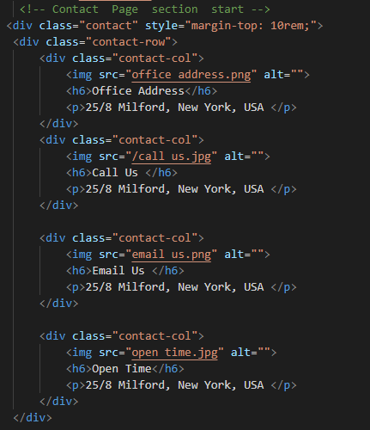

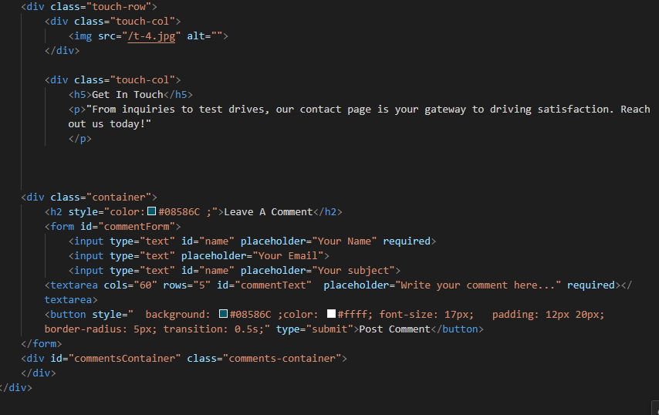

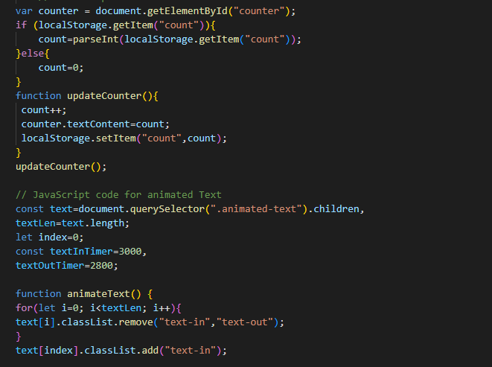

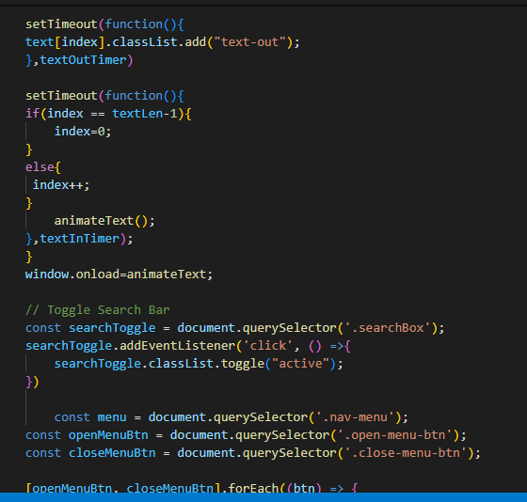

* This code creates a contact page section where you can find details like the office address, phone number, email, and opening hours. It also includes a form for users to leave comments or messages.

1. Counts how many times a webpage is loaded and stores it.
2. Creates a smooth text animation effect.
3. Allows toggling the visibility of a search bar.
4. Lets you open and close a menu by clicking buttons.

BLOGS:

  <!-- blog session start -->

         <div class="image1">

          <img src="BLOCK-MASTHEAD-1920x480-HOMEPAGE.avif" alt="" style="width: 100vw;">

       </div>

       <div class="image2">

         <a href="/pic.html"> <img src="/BLOCK-Kyle-Larson-Wins-in-Las-in-Vegas-MASTHEAD-3-1.avif" alt="" style="width:60vw; margin: 70px 40px;"></a>

          <h3>Chevrolet Thunders into 2024 NHRA Campaign</h3>

          <h5>A new NHRA season is set to blast off, and as always, Chevrolet power will be seen, felt <br> and heard on drag strips across the country…</h5>

       </div>

       <div class="menu1">

          <h2>TRENDING</h2> <hr>

      <div class="para1">

          <p>A Mighty Chevelle: This 1966 Convertible Features 502 Big-Block Power</p> <hr>

          <p>Blownaway: Jim Meyer’s 1967 Nova is an LS-powered Beauty</p> <hr>

          <p>Greg Anderson: A Pro Stock Life</p>

      </div>

          <h2>EDITOR'S PICKS</h2> <hr>

          <div class="para2">

              <p>On Course: This Second-Gen Camaro is Built for Autocross</p> <hr>

              <p>How Jake Velasco Race Prep Uses LS Power in the Desert</p> <hr>

              <p>COPO Counsel: Attorney Richard Ingram is a Racer at Heart</p>

          </div>

         <div class="image-trend">

          <img src="/23cp_retail_CC_resize 1080x2160.avif" alt="">

         </div>

       <div class="event">

          <h2>EVENTS</h2>

          <hr>

          <p>February 18</p>

          <b>Daytona 500</b>

          <p>Daytona Beach, FL (Daytona International Speedway)</p>

          <hr>

          <p>March 1-3</p>

          <b>Detroit Autorama</b>

          <p>Detroit, MI (Huntington Place)</p>

          <hr>

           <p>March 6-10</p>

          <b>BFGoodrich Tires Mint 400</b>

          <p>Primm, NV (Mint 400 Race Course)></p>

           <hr>

          <p>March 7-10</p>

          <b>NHRA Gatornationals</b>

          <p>Gainesville, FL (Gainesville Raceway)</p>

          <hr>

          <p>March 13-16</p>

          <b>Mobil 1 Twelve Hours of Sebring</b>

          <p>Sebring, FL (Sebring International Raceway)</p>

          <hr>

          <p>March 15-17</p>

          <b>Goodguys Spring Nationals</b>

          <p>Scottsdale, AZ (WestWorld of Scottsdale)</p>

       </div>

       </div>

       <section>

          <div class="blog">

          <!-- <h4 style="margin: -85rem 80px; font-size: 70px;"><i class="bx bx-car"></i>Our Blog</h4> -->

          <h1 style="margin: -406rem -20px;">...........Latest News & <span>Blog..........</span></h1>

          </div>

          <div class="container">

              <div class="ring"></div>

              <div style="margin:590rem -60px; margin-top: -218rem;" class="ring"></div> <br><br><br>

          </div>

          <div class="blog-row">

              <div class="blog-col">

                  <h5>Is It Better To Lease Or Buy A Car?</h5>

                  <p>Critical differences in ownership,  financial commitment, <br> and  flexibility arise in the long-standing debate of <br> whether to lease or buy a car. This article will <br> outline the key benefits and considerations <br> between leasing and buying a car. What is <br>the difference between leasing  and buying <br>a car? The key differences between …</p>

                      <div class="image">

                      <img src="img/type/02.png" alt="">

                  </div>

                  <a href="/blog_single.html">Read More<i class="bx bx-right-arrow-alt"></i> </a>

                  <div class="date">

                      <p><i class='bx bx-user-circle'></i>By Shaheen Khan</p>

                      <p><i class='bx bxs-calendar'></i>January 29,2024</p>

                  </div>

              </div>

              <div class="blog-col">

                  <h5>The Ultimate Guide to Understanding Car Warranties in the UK</h5>

                  <p>Navigating the world of car warranties in the UK can be a daunting task, especially when trying to find the perfect balance between cost and coverage. Whether you’re buying your first car or are a seasoned motorist considering a used car understanding the nuances of car warranty cover is essential. …</p>

                  <div class="image">

                      <img src="img/type/04.png" alt="">

                  </div>

                  <a href="/blog2.html">Read More <i class="bx bx-right-arrow-alt"></i> </a>

                  <div class="date">

                      <p><i class='bx bx-user-circle'></i>By Aliza Khan</p>

                      <p><i class='bx bxs-calendar'></i>Febuary 14,2024</p>

                  </div>

              </div>

              <div class="blog-col">

                  <h5>Top 6 Luxurious cars to consider in 2024</h5>

                  <p>Luxurious cars have always been sought after since the invention of the very first modern automobile in 1885. There is now a real demand for luxury cars. This article will list six of the most luxurious cars to consider buying in 2024. Why people buy luxury cars Everything in a …</p>

                  <div class="image">

                      <img src="img/type/10.png" alt="">

                  </div>

                  <a href="/blog3.html">Read More <i class="bx bx-right-arrow-alt"></i> </a>

                  <div class="date">

                      <p><i class='bx bx-user-circle'></i>By Amna Sohail</p>

                      <p><i class='bx bxs-calendar'></i>March 2,2024</p>

                  </div>

              </div>

              <div class="blog-col">

                  <h5>The Future on the Road: The Evolution of Autonomous Driving and a Master Class in Brake Pad Replacement</h5>

                  <p>In recent years, autonomous driving has become one of the most talked about topics in the automotive industry and beyond. Developments in this field promise to revolutionize the way we travel, make roads safer and significantly improve people’s quality of life. But what is the current state of autonomous driving …</p>

                  <div class="image">

                      <img src="img/type/11.png" alt="">

                  </div>

                  <a href="/blog4.html">Read More <i class="bx bx-right-arrow-alt"></i> </a>

                  <div class="date">

                      <p><i class='bx bx-user-circle'></i>By Alacia Davis</p>

                      <p><i class='bx bx-calendar'></i>April 12,2024</p>

                  </div>

              </div>

              <div class="blog-col">

                  <h5>When is the Best Time of Year to Look for New Citroen Vans for Sale</h5>

                  <p>For businesses and individuals considering a fleet upgrade or a new purchase, timing can be everything. When it comes to finding the best deals on new Citroen vans for sale, knowing the right time of year to start your search can lead to substantial savings and a smoother buying experience. …</p>

                  <div class="image">

                      <img src="img/type/08.png" alt="">

                  </div>

                  <a href="/blog5.html">Read More <i class="bx bx-right-arrow-alt"></i></a>

                  <div class="date">

                      <p><i class='bx bx-user-circle'></i>By Ayesha Mughal</p>

                      <p><i class='bx bxs-calendar'></i>June 4,2024</p>

                  </div>

              </div>

              <div class="blog-col">

                  <h5>Give Your Vehicle Some Love This Valentine’s Day</h5>

                  <p>As Valentine’s Day approaches, love is in the air, and it’s not just reserved for romantic partners. This year, consider showing some affection to a loyal partner that has been with you through thick and thin – your car. Just like any relationship, your car requires care and attention to …</p>

                  <div class="image">

                      <img src="img/type/09.png" alt="">

                  </div>

                  <a href="/blog6.html">Read More <i class="bx bx-right-arrow-alt"></i> </a>

                  <div class="date">

                      <p><i class='bx bx-user-circle'></i>By Ali Dawood</p>

                      <p><i class='bx bxs-calendar'></i>August 9,2024</p>

                  </div>

              </div>

          </div>

         <div style="margin: 860px 57px; width: 65rem;" class="hr"><hr></div>

          <div class="offer">

              <img src="/23cp_retail_CC_resize 3492x360.avif" alt="" style="margin: -597rem 42px; width: 60vw; margin-top: 316rem;">

          </div>

          <div class="video">

              <h2>LATEST VIDEOS</h2>

              <iframe width="700" height="315" src="https://www.youtube.com/embed/3MmQEWBPUc4?si=4L8uIi4xZMvTf_Aa" title="YouTube video player" frameborder="0" allow="accelerometer; autoplay; clipboard-write; encrypted-media; gyroscope; picture-in-picture; web-share" allowfullscreen></iframe>

          </div>

  <div class="short-video">

      <div class="vid1">

          <iframe width="200" height="130" src="https://www.youtube.com/embed/XjOkF5-AgRs?si=0XOSGII1SQZDoaxx" title="YouTube video player" frameborder="0" allow="accelerometer; autoplay; clipboard-write; encrypted-media; gyroscope; picture-in-picture; web-share" allowfullscreen></iframe>

          <h3>Circle Track Crate Engines | 2022 PRI Trade Show</h3>

      </div>

      <div class="vid2">

          <iframe width="200" height="130" src="https://www.youtube.com/embed/BxP3dx8U67g?si=KzLKCxk7c9YvEK_r" title="YouTube video player" frameborder="0" allow="accelerometer; autoplay; clipboard-write; encrypted-media; gyroscope; picture-in-picture; web-share" allowfullscreen></iframe>

          <h3>2023 COPO Camaro | 2022 PRI Trade Show</h3>

      </div>

      <div class="vid3">

          <iframe width="200" height="130" src="https://www.youtube.com/embed/BxP3dx8U67g?si=YIbfeTSlWzMqWvCD" title="YouTube video player" frameborder="0" allow="accelerometer; autoplay; clipboard-write; encrypted-media; gyroscope; picture-in-picture; web-share" allowfullscreen></iframe>

          <h3>Moores Garage | 1964 Corvette | 2022 PRI Trade Show</h3>

      </div>

  </div>

  <div class="more-from">

  <div class="row">

      <h1>MORE FROM</h1>

      <div class="column">

        <a href="/vehicle.html"><img src="/image_copy_copy_copy_865415854.avif" alt="" style="width:100%">

        <p>VEHICLES</p> </a>

      </div>

      <div class="column">

        <a href="/part.html"><img src="/image_copy_800183129.avif" alt="" style="width:100%">

        <p>PARTS</p> </a>

      </div>

      <div class="column">

        <a href="/event.html"><img src="/image_copy_1649523252.avif" alt="" style="width:100%">

        <P>EVENTS</P></a>

      </div>

      </div>

  </div>

       <div class="col-1">

          <video controls autoplay muted >

              <source src="/fb40ccca4029f27fadde063c04479645 - Copy - Copy (2).mp4" type="video/mp4">

          </video>

         </div>

       </section>

here's a brief explanation of the provided HTML code:

1. The code represents a blog section of a website related to automotive content.
2. It includes sections for images, trending/editor's picks, upcoming events, blog posts, videos, and more.
3. Each blog post has a title, excerpt, image, author information, and publication date.
4. There are links to individual blog posts and other sections like vehicles, parts, and events.
5. The code also embeds YouTube videos and includes images related to promotions/offers.

Overall, it's a structured layout for a dynamic automotive blog with multimedia content and navigation elements.

/* blog styling */

.image2 h3{

  color: #077bc1;

  font-family: sans-serif;

  font-size: 30px;

  margin: -60px 70px;

}

.image2 h5{

  margin: 70px;

  font-size: 20px;

}

.image2 h5::after{

  content:'';

  width: 0;

  height: 3px;

  background-color: var(--lake-color);

  margin: 0px 60px;

  display: block;

  position: relative;

}

.image2 h5:hover::after{

  width: 62rem;

  transition: width 0.4s linear;

  /* width: 30vw; */

  margin-top:8px;

}

.image2 h5:hover{

  color: rgba(15, 95, 214, 0.792);

  cursor: pointer;

}

.blog{

  display: flex;

  flex-direction: column;

  margin: -30px 40px;

  padding: 7.5rem 8.5%;

}

.blog h4{

  font-family: sans-serif;

  font-size: 25px;

  color: #08586C;

}

.container{

  position: relative;

  width: 30px;

  height: 30px;

  display: flex;

  justify-content: center;

  align-items: center;

}

.container .ring{

  position: relative;

  width: 46px;

  height: 55px;

  margin: 0px -200px;

  border-radius: 50%;

  border: 4px solid transparent;

  animation: animate 4s linear infinite;

}

.container .ring:nth-child(2){

  animation: animate2 4s linear infinite;

  animation-delay: -1s;

  border-left: 4px solid #024f63;

  border-top: 4px solid transparent;

}

@keyframes animate2

{

  0%{

      transform: rotate(360deg);

  }

  100%{

      transform: rotate(0deg);

  }

}

.container .ring:nth-child(3){

  animation: animate2 4s linear infinite;

  animation-delay: -3s;

  border-top: 4px solid transparent;

  border-left: 4px solid #010718;

  position: absolute;

  top: -66.66px;

}

.blog h1{

  font-size: 45px;

  font-family: sans-serif;

}

.blog h1 span{

  color: var(--main-color);

}

.blog i{

  color: var(--main-color);

}

.blog-row{

  display: block;

  grid-template-columns: repeat(1,1fr);

  gap: 40px;

  margin: -402rem 73px;

  width: 71rem;

}

.blog-row .blog-col{

box-shadow: 0 0 10px #d8d3d3;

padding: 16px 20px 30px;

border-radius: 10px;

text-align: left;

background-color: #fff;

overflow: hidden;

/* height: 50rem; */

}

.blog-col .image{

  width: 34rem;

  height: 24rem;

  /* overflow: hidden; */

  border-radius: 10px;

  margin-left: 336px;

}

.blog-row .blog-col .image img{

  width: 100%;

  height: 100%;

  border-radius: 10px;

  object-fit: cover;

  transition: 0.5s;

}

.blog-row .blog-col:hover .image img{

  transform: scale(1.1);

}

.blog-row .blog-col .date{

  display: flex;

  justify-content: left;

  gap: 20px;

  padding: 15px 0;

  border-bottom: 1px solid #d8d3d3;

}

.blog-row .blog-col .date p{

  color: var(--text-color);

  font-size: 14px;

  font-family: 'poppins' , sans-serif;

}

.blog-row .blog-col .date p i{

  color: var(--main-color);

  font-size: 15px;

}

.blog-row .blog-col h5{

  padding: 20px 0 30px;

  font-size: 32px;

  letter-spacing: 1px;

  color: #189ab4;

  font-family: 'poppins' , sans-serif;

  font-weight: 550;

}

.blog-row .blog-col a{

  background-color: var(--main-color);

  color: #ffff;

  padding: 12px 30px 12px 20px;

  font-size: 16px;

 border-radius: 8px;

 position: relative;

 transition: 0.5s;

}

.blog-row .blog-col a i{

  position: absolute;

  top: 14px;

  font-size: 20px;

}

.blog-row .blog-col a:hover{

  background-color: var(--text-color);

}

.blog-row .blog-col p{

  font-size: 30px;

}

.blog-row .blog-col::after{

  content:'';

  width: 0;

  height: 3px;

  background-color: var(--lake-color);

  margin: 0px 60px;

  display: block;

  position: relative;

}

.blog-row .blog-col:hover::after{

  width: 62rem;

  transition: width 0.4s linear;

  /* width: 30vw; */

  margin-top:8px;

}

.blog-row .blog-col:hover{

  color: rgba(15, 95, 214, 0.792);

  cursor: pointer;

}

.video{

  background: rgb(171, 196, 204);

  margin: 603rem 40px;

  width: 128rem;

  height: 500px;

}

.short-video{

  margin-top: -651.3rem ;

}

.video h2{

  margin: 30px;

  font-size: 40px;

  font-family: sans-serif;

}

.vid1{

  margin: 30.8rem 80rem;

}

.vid1 h3{

  display: flex;

  position: absolute;

  /* margin: 20px 12rem; */

  margin: -12rem 19.5rem;

  font-size: 14px;

  padding-left: 40px;

}

.vid2{

  margin: -30rem 80rem;

}

.vid2 h3{

  display: flex;

  position: absolute;

  /* margin: 20px 12rem; */

  margin: -12rem 19.5rem;

  font-size: 14px;

  padding-left: 40px;

}

.vid3{

  margin: 31rem 80rem;

}

.vid3 h3{

  display: flex;

  position: absolute;

  /* margin: 20px 12rem; */

  margin: -12rem 19.5rem;

  font-size: 14px;

  padding-left: 40px;

}

.menu1{

  margin: -47rem 90rem;

  display: block;

}

.menu1 h2{

  font-size: 30px;

  font-weight: bold;

  font-family: sans-serif;

  color: #08586C;

}

.menu1 hr{

width: 32rem;

}

.menu1 p{

 display: inline-block;

  font-size: 20px;

}

.menu1 .image-trend img{

  width:22rem;

  height: 42rem;

  margin-top: 5rem;

}

.menu1 hr::after{

  content:'';

  width: 0;

  height: 3px;

  background-color: var(--lake-color);

  margin: 0px 60px;

  display: block;

  position: relative;

}

.menu1 hr:hover::after{

  width: 62rem;

  transition: width 0.4s linear;

  /* width: 30vw; */

  margin-top:8px;

}

.menu1:hover{

  color: rgba(15, 95, 214, 0.792);

  cursor: pointer;

}

.menu1 hr:hover{

  height:1.5rem;

  color: var(--main-color);

}

.event h2{

  margin-top: 5rem;

}

.event p{

  /* position: absolute; */

  display: flex;

  margin: 20px 0px;

}

.event b{

  font-size: 3rem;

  display: flex;

  margin: 30px 0;

}

.more-from .row h1{

  text-align: center;

  font-family: sans-serif;

  font-size: 4rem;

  margin: 9rem 1rem ;

  flex-wrap: wrap;

  font-weight: 700;

  color: var(--main-color);

}

.row {

  display: flex;

  margin-top: -284px;

}

.column {

  flex: 33.33%;

  padding: 5px;

  margin: -4rem 0;

}

.column p{

  font-size: 2.3rem;

  font-family: sans-serif;

  font-style: normal;

  font-weight: 500;

 text-align: center;

 color: var(--main-color);

}

.column a::after{

  content:'';

  width: 0;

  height: 3px;

  background-color: var(--cyan-color);

  margin: auto;

  display: block;

  position: relative;

}

.column a:hover::after{

  width: 100%;

  transition: width 0.4s linear;

  margin-top:8px;

}

.column a:hover{

  color: rgba(15, 95, 214, 0.792);

  cursor: pointer;

  text-decoration: none;

}

.col-1 video{

  width: 118rem;

  height: 50rem;

  object-fit: cover;

  margin: 12rem 8rem;

}

@media(max-width:1160px){

  .blog .blog-row{

      grid-template-columns: repeat(2,1fr);

  }

}

@media(max-width:768px){

  .blog .blog-row{

      grid-template-columns: repeat(1,1fr);

  }

  .blog-row .blog-col image{

      height: auto;

  }

}

/* For screens up to 650px */

@media screen and (max-width: 445px) {

  .image-1 {

    width: 100%; /* Make the image fill the container */

    height: auto; /* Ensure aspect ratio is maintained */

  }

}

/* For screens from 651px to 991px */

@media screen and (min-width: 445px) and (max-width: 991px) {

  .image-1 {

    width: 80%; /* Adjust the width as needed */

    height: auto; /* Ensure aspect ratio is maintained */

  }

}

/* For screens from 992px to 1120px */

@media screen and (min-width: 992px) and (max-width: 1120px) {

  .image-1 {

    width: 60%; /* Adjust the width as needed */

    height: auto; /* Ensure aspect ratio is maintained */

  }

}

This code is a CSS stylesheet for styling a blog website. It includes styling for various elements such as headings, paragraphs, images, videos, menus, events, and more. Here's a brief explanation of the key parts:

* **Selectors targeting headings (h3, h4, h5, h1) and paragraphs (p):** Sets styles like font size, color, margin, and font family for different heading and paragraph levels.
* **Selectors targeting specific classes like .image2, .blog, .blog-row, .blog-col, .video, .menu1, .event, .more-from, .row, .column, .col-1, etc.:** These classes are used to style specific sections or elements within the blog layout.
* **Animation (@keyframes):** Defines animations for elements with classes like **.container .ring**, creating rotating rings.
* **Media queries:** Adjusts styles based on different screen sizes (**max-width** and **min-width** conditions).

Overall, the code organizes styles for different parts of the blog layout, including text, images, videos, menus, events, and responsive design for various screen sizes.

<!DOCTYPE html>

<html lang="en">

<head>

    <meta charset="UTF-8">

    <meta name="viewport" content="width=device-width, initial-scale=1.0">

    <title>Blog Page-1</title>

    <link href='https://unpkg.com/boxicons@2.1.4/css/boxicons.min.css' rel='stylesheet'>

    <link  href="https://cdn.jsdelivr.net/npm/swiper@11/swiper-bundle.min.css"/>

    <link href="https://cdn.jsdelivr.net/npm/remixicon@4.1.0/fonts/remixicon.min.css" rel="stylesheet">

    <link rel="stylesheet" href="/blog_single.css">

</head>

<body>

         <!-- blog single session start -->

        <div class="blog-single">

          <div class="left">

            <img src="/img/home/bg-hero-3.jpg" alt="" style="width: 80vw; height: 60vh;">

            <div class="row">

                <div class="col">

                    <p><i class="bx bxs-user"></i>Jean R Gunter</p>

                    <p><i class="bx bxs-chat"></i>3.2k Comment</p>

                    <p><i class="bx bxs-like"></i>1.4k Likes</p>

                <p><i class="bx bx-share-alt"></i>Share</p>

                </div>

            </div>

            <h4>Is It Better To Lease Or Buy A Car?</h4>

            <p>Critical differences in ownership, financial commitment, and flexibility arise in the long-standing <br>debate of whether to lease or buy a car.</p>

            <p>This article will outline the key benefits and considerations between leasing and buying a car. <br> What is the difference between leasing and buying a car? The key differences between …</p>

         <div class="image">

            <img src="/img/blog/01.jpg" alt="" style="width: 40vw; height: 51vh; flex-wrap: wrap;">

            <img src="img/blog/02.jpg" alt="" style="width: 40vw; height: 51vh; flex-wrap: wrap; margin-left: 35px;">

         </div>

         <h3 style="font-size: 2rem; color: #08586C; margin-top: 20px; text-align: center;">What is the difference between leasing and buying a car?</h3>

         <p>The key differences between buying and leasing a car are ownership, financial commitment, <br> and flexibility. <br> <br>

           <b>1.Ownership: </b> When you buy a car, you own it outright. Ownership means you can do whatever <br> you want with it, such as sell it, trade it in, or modify it. When you lease a car, you don’t own it. <br> You’re simply renting it from the dealership for some time. <br> <br>

           <b>2. Financial commitment: </b>Buying a car requires a larger upfront payment than leasing a car. <br> This is because you’re paying for the entire cost of the vehicle. Leasing a car requires a smaller <br> upfront fee, but you’ll have monthly payments for the duration of the lease. <br> <br>

           <b>3. Flexibility: </b>Buying a car gives you more flexibility than leasing a vehicle. You can sell it or <br> trade it whenever you want. You can also modify it however you want. With a lease, <br> you’re locked into a contract for some time. You can’t sell the car or trade it in without paying <br> a penalty. You also can’t modify the car without the dealership’s permission.</p> <br>

         <div class="tags">

            <h6>Tags:</h6>

            <span>Car</span>

            <span>Dealer</span>

            <span>Shop</span>

         </div>

         <div class="author">

            <img src="/images (2).jfif" alt="">

            <div class="info">

                <h5>Author</h5>

                <h4>Ronger D Duque</h4>

                <p>"Behind every car is a story, and in the hands of its owner, that story unfolds with each mile traveled, each destination reached."</p>

                <div class="social">

                    <a href="https://www.facebook.com/login.php?skip_api_login=1&api_key=966242223397117&signed_next=1&next=https%3A%2F%2Fwww.facebook.com%2Fsharer%2Fsharer.php%3Fu%3Dhttps%253A%252F%252Fwww.chevrolet.com%252Fthe-block%252Farticles%252F2024%252Fmarch%252Fchevrolet-thunders-into-2024-nhra-campaign&cancel_url=https%3A%2F%2Fwww.facebook.com%2Fdialog%2Fclose_window%2F%3Fapp_id%3D966242223397117%26connect%3D0%23_%3D_&display=popup&locale=en_GB"><i class="ri-facebook-circle-fill"></i></a>

                <a href="https://www.instagram.com/accounts/login/?hl=en"><i class="ri-instagram-line"></i></a>

                <a href="https://www.linkedin.com/login"><i class="ri-linkedin-box-line"></i></a>

                <a href="https://web.telegram.org/"><i class="ri-telegram-line"></i></a>

                <a href="https://twitter.com/login"><i class="ri-twitter-line"></i></a>

                </div>

            </div>

         </div>

         <div class="comment">

            <h4>Customers Comments</h4>

            <div class="row">

                <img src="img/invectory/com-1.jpg" alt="">

                <div class="info">

                    <h6>Jasmine Sinker</h6>

                    <span><i class="bx bx-share-alarm"></i>January 31,2023</span>

                    <p>My first question was: “Why Puma?”, but DNA from the original coupe still exists here — especially in the new car’s face. Scratchy plastics are aplenty in the cabin, but nice touches such as fabric-trimmed door cards and physical heater controls make you quickly forget about that.

                    </p>

                    <span><i class="bx bx-share"></i>Reply</span>

                </div>

            </div>

            <div class="row">

                <img src="img/invectory/com-2.jpg" alt="">

                <div class="info">

                    <h6>Hafsa Memon</h6>

                    <span><i class="bx bx-share-alarm"></i>March 2,2024</span>

                    <p>Hyundai invited me to drive some of its newest cars in Edinburgh — a 57-mile round trip of mostly motorways and a bit of town driving. You may be surprised, but the 125bhp 1.0-litre E

coboost did remarkably well and at no point was I frustrated with its pickup.</p>

                    <span><i class="bx bx-share"></i>Reply</span>

                </div>

            </div>

            <div class="row">

            <img src="img/invectory/com-3.jpg" alt="">

            <div class="info">

                <h6>Jaweria Khan</h6>

                <span><i class="bx bx-share-alarm"></i>April 11,2021</span>

                <p>The week was over, the keys were handed back and the Kuga had given me mixed feelings. The driving experience could be engaging, but the sport suspension was a tad too much when I wasn’t in the mood for driving around with my hair alight. For that reason, I would opt for either the Titanium or Vignale editions for a softer ride.</p>

                <span><i class="bx bx-share"></i>Reply</span>

            </div>

            </div>

            <div class="right">

            <div class="follow">

                <h4>Follow us</h4>

                <a href="https://www.facebook.com/login.php?skip_api_login=1&api_key=966242223397117&signed_next=1&next=https%3A%2F%2Fwww.facebook.com%2Fsharer%2Fsharer.php%3Fu%3Dhttps%253A%252F%252Fwww.chevrolet.com%252Fthe-block%252Farticles%252F2024%252Fmarch%252Fchevrolet-thunders-into-2024-nhra-campaign&cancel_url=https%3A%2F%2Fwww.facebook.com%2Fdialog%2Fclose_window%2F%3Fapp_id%3D966242223397117%26connect%3D0%23_%3D_&display=popup&locale=en_GB"><i class="ri-facebook-circle-fill"></i></a>

                <a href="https://www.instagram.com/accounts/login/?hl=en"><i class="ri-instagram-line"></i></a>

                <a href="https://www.linkedin.com/login"><i class="ri-linkedin-box-line"></i></a>

                <a href="https://web.telegram.org/"><i class="ri-telegram-line"></i></a>

                <a href="https://twitter.com/login"><i class="ri-twitter-line"></i></a>

            </div>

            </div>

            <div class="container">

                <h2 style="color:#08586C ;">Leave A Comment</h2>

                <form id="commentForm">

                    <input type="text" id="name" placeholder="Your Name" required>

                    <input type="text" placeholder="Enter Posted Date">

                <textarea cols="60" rows="5" id="commentText"  placeholder="Write your comment here..." required></textarea>

                <button style="  background: #08586C ;color: #ffff; font-size: 17px;   padding: 12px 20px;  border-radius: 5px; transition: 0.5s;" type="submit">Post Comment</button>

            </form>

            <div id="commentsContainer" class="comments-container">

            </div>

        </div>

          <script>

            document.getElementById('commentForm').addEventListener('submit', function(event) {

              event.preventDefault(); // Prevent form submission

              // Get the name, comment text, and current date

              var name = document.getElementById('name').value;

              var commentText = document.getElementById('commentText').value;

              var date = new Date().toLocaleString();

              // Create a new comment element

              var commentElement = document.createElement('div');

              commentElement.classList.add('comment');

              commentElement.innerHTML = '<p><strong>' + name + '</strong> - ' + date + '</p><p>' + commentText + '</p>';

              // Get the comments container

              var commentsContainer = document.getElementById('commentsContainer');

              // Insert the new comment at the beginning of the comments container

              commentsContainer.insertBefore(commentElement, commentsContainer.firstChild);

              // Clear the comment input

              document.getElementById('name').value = '';

              document.getElementById('commentText').value = '';

            });

            </script>

</body>

</html>

This HTML code represents a blog single page. Here's a breakdown of its structure and functionality:

1. **Meta tags**: These tags provide metadata information about the HTML document, such as character set and viewport settings.
2. **External CSS links**: Links to external CSS files from Box icons, Swiper, and Remixicon for styling the page.
3. **Internal CSS link**: Links to an internal CSS file named "blog_single.css" for additional styling.
4. **Body content**:
   * The main content starts with a **div** element with a class of "blog-single".
   * Inside this **div**, there's a **div** with a class of "left" containing various elements like an image, author info, comments section, etc.
   * The image is wrapped in a **div** with a class of "image" and contains two images displayed side by side.
   * Text content includes headings (**h4**, **h3**), paragraphs (**p**), and lists (**ul**, **li**) to provide information about the blog post.
   * The "Tags" and "Author" sections provide additional information and social media links.
   * The "Comments" section displays comments from users along with a form to submit new comments.
   * JavaScript code is included at the end to handle form submission for posting comments dynamically without page reload.
5. **JavaScript**:
   * The JavaScript code listens for the form submission event and prevents the default form submission behavior.
   * It collects input values (name, comment text) and generates a new comment element with the user's input and current date.
   * The new comment is then added to the comments container, and the form inputs are cleared for the next comment.

Overall, this HTML code creates a structured blog single page with content, images, comments section, and interactive form submission for

|  |  |  |  |  |  |  |
| --- | --- | --- | --- | --- | --- | --- |
| Project Ref. No.: eP/Advertisement Portal Management System/01 | | Project title | Date of Preparation of Activity Plan | | | |
| No | Task |  |  | Actual | Team-mate | Status |
| Start Date of project | Days | Names |
| 1 | Header and Banner | 18/feb/2024 | 3 | Hafsa | Complete |
| 2 | Home Page | “ | 10 | Saba | Complete |
|  | Blogs |  |  |  |  |
| 3 |  |  | “ | 15 | Anmol | Complete |
|  |  | Car  Breezy |  |  |  |  |
| 4 | Categories | “ | 2 | Saba | Complete |
| 5 | Accessories | “ | 7 | Hafsa | Complete |
|  | About | “ |  |  |  |
| 6 |  |  |  | 3 | Hafsa | Complete |
|  |  |  |  |  |  |

|  |  |  |  |  |  |  |
| --- | --- | --- | --- | --- | --- | --- |
| 6 | Contact |  | “ | 10 | Hareem | Complete |

THANK YOU……